Lab 7: Charging and Discharging of RC circuits

1. What is time verifying signal?

Ans: A signal whose values changes with time

1. What is peak voltage?

Ans: maximum voltage of a signal. It is often denoted by Vp

1. What is time period?

Ans: Time required to complete 1 cycle. It is denoted by T.

1. What is frequency?

Ans: No. of cycles completed in 1 second. It is denoted by f. Its unit is in Hz.

1. What is signal generator? How many types of signal do you get from signal generator?

Ans: Signal generator is a device that allows you to generate a time varying signal that have a particular frequency and amplitude (Vp). You can adjust your time period by adjusting your frequency. Sin, Square, Triangular wave – 3 types of signals are got from signal generator.

1. What is oscilloscope?

Ans: a device for viewing oscillations by a display on the screen of a cathode ray tube

1. What is capacitor?

Ans: Capacitor is an electronic component that stores electric charge.

1. How capacitor charged and discharged in the circuit?

Ans: When a Capacitor is connected to a circuit with Direct Current (DC) source, two processes, which are called "charging" and "discharging" the Capacitor, will happen in specific conditions. A Capacitor is equivalent to an Open-Circuit to Direct Current, R = ∞, because once the Charging Phase has finished, no more Current flows through it. The Voltage vc on a Capacitor cannot change abruptly. When the Capacitor disconnected from the Power Supply, the Capacitor is discharging through the Resistor RD and the  
Voltage between the Plates drops down gradually to zero, vc = 0

1. What is time constant? How many times do the capacitor need to fully charge and discharged?

Ans: The RC time constant, also called tau, the time constant (in seconds) of an RC circuit, is equal to the product of the circuit resistance (in ohms) and the circuit capacitance (in farads).

A capacitor, C charges up through the resistor until it reaches an amount of time equal to 5 time constants or 5T and then remains fully charged. It is the time required to charge the capacitor, through the resistor,

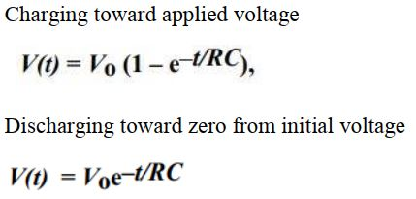

from an initial charge voltage of zero to ≈63.2 percent of the value of an applied DC voltage, or to discharge the capacitor through the same resistor to ≈36.8 percent of its initial charge voltage.

Lab 6: Verification of Thevenin’s, Norton’s and Maximum Power Transfer Theorem

1. What is thevenin theorem?

Ans: Thevenin’s Theorem states that it is possible to simplify any linear circuit, no matter how complex, to an equivalent circuit with just a single voltage source and series resistance connected to a load. The Thévenin equivalent circuit consists of a single dc source referred to as the Thévenin voltage (VTH ) and a single fixed resistor called the Thévenin resistance (RTH)

1. What is Norton theorem?

Ans: Norton’s Theorem states that it is possible to simplify any linear circuit, no matter how complex, to an equivalent circuit with just a single current source (IN ) and parallel resistance connected to a load (RN )

1. What is maximum power transfer theorem?

Ans: Maximum Power will be delivered to the load when that load resistance is equal to the Thevenin / Norton resistance of the network supplying the power. If the load resistance is lower or higher than the Thevenin / Norton resistance of the source network, its dissipated power will be less than maximum.

Pmax = IL2RL = VTH2 / 4RTH

1. Relationship between Norton and thevenin.

Ans:

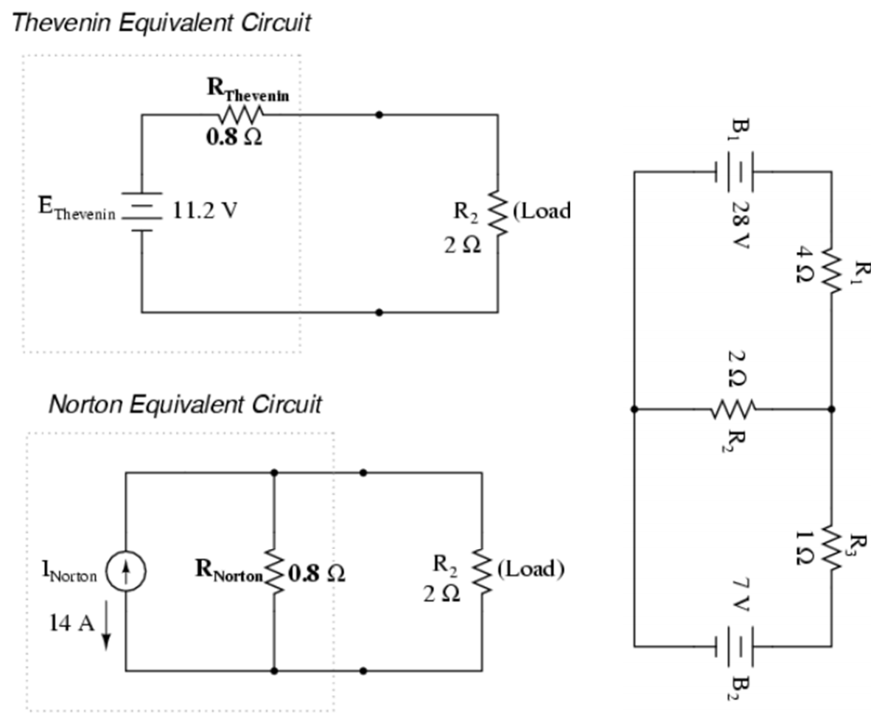

RN = RTH and ETH = INRTH . Here, Load resistance is R2

1. Applications of thevenin, Norton and maximum power theorem.

Ans: Thevenin and Norton theorem are used where the load can be varied. So basically these methods reduce the big linear circuit into one source and one resistor. Later we can put any kind of load and measure the variations of currents and voltages across the load. Also where maximum power is required from source, these theorem are used to calculate required load impedance or present source impedance for maximum power.

Lab 5: Delta-Wye Conversion

1. What is delta wye transformation?

Ans: The ∆ -Y transform, also written as delta-wye and also known by many other names is a mathematical  
technique to simplify the analysis of three phase electric power circuits. The ∆ -Y transform can be considered as a special case of the star mesh transform for three resistors. It plays an important role in the theory of circular plane graphs. This is also referred to as a Pi - T transformation

1. Importance of delta wye transformation

Ans: Delta-Wye Transformation is very important in Circuits, sometimes we are not sure in electric circuits that the resistors are neither parallel nor series. In many circuit applications, we encounter components connected together in one of two ways to form a three-terminal network: the “Delta,” or Δ (also known as the “Pi,” or π) configuration, and the “Y” (also known as the “T”) configuration.

* “Delta” (Δ) networks are also known as “Pi” (π) networks.
* “Y” networks are also known as “T” networks
* Δ and Y networks can be converted with the proper resistance equations. By “equivalent,” I mean that the two networks will be electrically identical as measured from the three terminals (A, B, and C).

1. How to connect delta wye connection?

Ans: 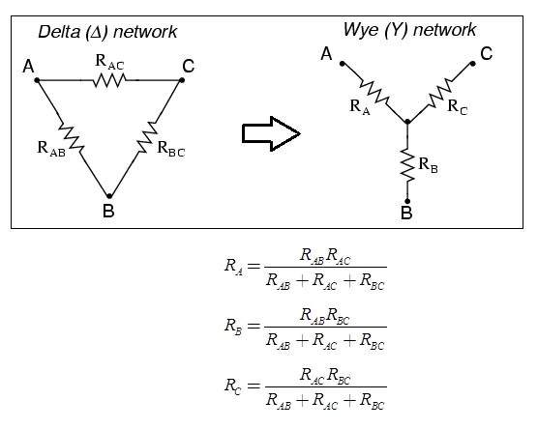

1. How to connect Wye delta connection?

Ans: 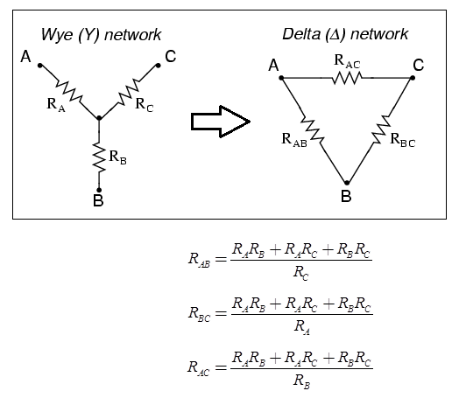

1. Application of delta wye connection

Ans: Star-Delta connection in three phase circuits is used to vary voltage and current. If you use star connection then voltage is reduced to 60% of supply voltage and current remains same while in Delta connection current is reduced to 60% of the value of current in star connection. Its major application is in starting induction motor where it need starting at low voltage to keep starting current low, it is started in star ie its three windings are connected in star but induction motor needs to be operated at high voltage at steady state or normal state to deliver rated power, after starting in star its three windings are switched to delta.

Lab 4: Verification of Superposition Theorem

1. What is superposition theorem?

Ans: The superposition theorem for [electrical circuits](https://en.wikipedia.org/wiki/Electrical_network) states that for a linear system the response ([voltage](https://en.wikipedia.org/wiki/Voltage) or [current](https://en.wikipedia.org/wiki/Electric_current)) in any branch of a bilateral [linear circuit](https://en.wikipedia.org/wiki/Linear_circuit) having more than one independent source equals the algebraic sum of the responses caused by each independent source acting alone, where all the other independent sources are replaced by their internal [impedances](https://en.wikipedia.org/wiki/Electrical_impedance).

1. When the superposition theorem is used?

Ans: when there is more than one source

1. Application of superposition theorem

Ans: Superposition theorem is applied when we are to determine the current in one particular branch of a network containing several voltage sources and/or current sources.

1. Limitations of superposition theorem

Ans: 1. This theorem cannot be used to measure power.  
2. This theorem is not applicable to unbalanced bridge circuits.  
3. Applicable only to linear circuits.  
4. Applicable only for the circuits having more than one source.

Lab 3: Loading Effect of Voltage Divider Circuit

1. What is voltage divider rule?

Ans: The voltage is divided between two series resistors in direct proportion to their resistance.

1. What is loading effect?

Ans: When an instrument of lower sensitivity is used with a heavier load the measurement it makes is erroneous, this effect is known as loading effect.

1. What is potentiometer?

Ans: A potentiometer is a three-[terminal](https://en.wikipedia.org/wiki/Terminal_(electronics)) [resistor](https://en.wikipedia.org/wiki/Resistor) with a sliding or rotating contact that forms an adjustable [voltage divider](https://en.wikipedia.org/wiki/Voltage_divider).

1. Application of potentiometer.

Ans: Increases or decreases resistance. Potentiometers are commonly used to control electrical devices such as volume controls on audio equipment. Potentiometers operated by a mechanism can be used as position [transducers](https://en.wikipedia.org/wiki/Transducer), for example, in a [joystick](https://en.wikipedia.org/wiki/Joystick). Potentiometers are rarely used to directly control significant power (more than a [watt](https://en.wikipedia.org/wiki/Watt)), since the power dissipated in the potentiometer would be comparable to the power in the controlled load.

Lab 2: KCL, Current Divider Rule with Parallel and Ladder Circuit

1. Define current divider rule.

Ans: The electrical current entering the node of a parallel circuit is divided into the branches. Current divider formula is employed to calculate the magnitude of divided current in the circuits.

1. State KCL.

Ans: States that for a parallel path the total current entering a circuits junction is exactly equal to the total current leaving the same junction. Σ IIN = Σ IOUT

1. What is called ladder circuit?

Ans: Ladder circuit is a combination of series and parallel

1. What is color coding?

Ans: An electronic color code is used to indicate the values or ratings of electronic components, usually for [resistors](https://en.wikipedia.org/wiki/Resistor), but also for [capacitors](https://en.wikipedia.org/wiki/Capacitor), [inductors](https://en.wikipedia.org/wiki/Inductor), [diodes](https://en.wikipedia.org/wiki/Diode) and others.

1. Application of ladder circuit.

Ans: The ladder circuit represents a commonly used circuit style that is configured purely on the basis of series and parallel connection.

Lab 1: Ohm’s Law, KVL, and Voltage Divider Rule using Series Circuit

1. What is ohm’s law?
2. What is VDR?

Ans: The voltage is divided between two series resistors in direct proportion to their resistance.

1. What is resistor color code?

Ans: Resistor values are often indicated with color codes. For a 4 band resistor, AB x 10C with the tolerance of ± t%. is the value of resistor.

1. How do you measure the resistance theoretically?
2. What is KVL?

Ans: states that, in any closed loop network, the total voltage around the loop is equal to the sum of all the voltage drops within the same loop.

1. What is DMM? How do you measure voltage and current theoretically?

Ans: DMM is used to measure resistance, current and voltage.

1. What is called % of error?

Ans: % Error = (Theoretical value – Experimental Value) / Theoretical Value

1. What is breadboard?

Ans: A breadboard is a solderless device for temporary prototype with electronics and test circuit designs.

1. Application and importance of ohm’s law